Note: Include this page only when adding / amending / deleting a document. If using this document as a record, this Revision History page can be omitted.

REVISION HISTORY

Revision no | Date | Description of Changes | Reason for Revision | Revised by | Approvedby
1 | 19 Apr 13 | - Add revision history page | - Recommendation from Stage 2 audit | RDPlacido
3 | 1 Dec 15 | - Added Disclaimer  - “Admin” was changed to “Sales & Marketing” in References and Quality Records sections  -”Financial Statement” was changed to “Financial Report” in References, Quality Records, and Note 2  - Changed the schedule of the meeting in Note 1 | - Printing is sole responsibility of the person who printed it  - For more appropriate descriptions  - Corrected the term used.  - To consider closing of accounting transactions. | RCGanal | ECVentura

- Objective

To review the company's performance related to:

- the improvement and the effectiveness of the quality management system and its processes
- resources requirements
- status of preventive and corrective actions
- follow-up actions from previous management reviews

- Scope

This procedure defines the agenda discussed the monthly performance review which is attended by the management committee. The main objective of the meeting is to review the effectiveness of the quality management system, specifically the KPMs and CPIARs and that actions and preventive actions are set to improve the company's products and services.

- Definition of Terms

None

- Procedure Details

RESPONSIBLE | ACTIVITY | INTERFACE
President  All units heads  President  ManCom  President | 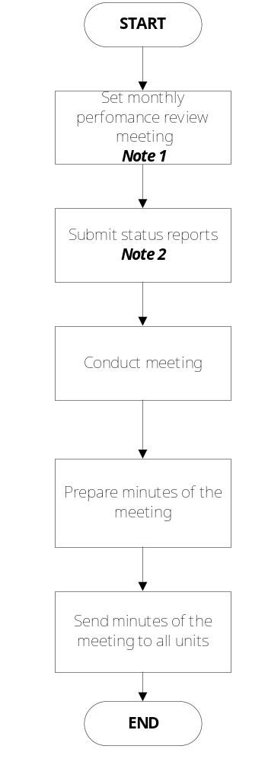 | Meeting Agenda/ Minutes  President &  Vice President  all reports below

Notes:

- The monthly performance review is set during the week of the second pay day (25th) of the month.

- The following reports are submitted to the president:

- Status of KPMs
- Status of CPIAR
- Summary of Movements Report
- Summary of Disciplinary Actions Report
- Headcount Report
- Financial Report as of end of the previous month

2. A meeting is held to discuss above topics.

- References
- Minutes of the Meeting Template
- Unit Reports

HR | - Headcount Report  - Summary of Disciplinary Action Report  - Summary of Movements Report
QMR | Status of CPIARs
Sales & Marketing | - Office Maintenance & Admin Report  - Inventory Report
ALL | Status of KPMs
Finance | Financial Report

- Quality Records
- Monthly Management Review Agenda & Minutes
- Unit Reports

HR | - Headcount Report  - Summary of Disciplinary Action Report  - Summary of Movements Report
QMR | Status of CPIARs
Sales & Marketing | - Office Maintenance & Admin Report  - Inventory Report
ALL | Status of KPMs
Finance | Financial Report

